**­­Munich vehicle load report 09/07/2022**

**Zeinab Nezami**

**Research Fellow at the University of Leeds**

This report study the input vehicle load to a sample area of Munich city.

We have chosen an area of about 7 square kilometers of Munich to conduct our experiments. This area is shown in figure.1 and has the following specifications:

Area in meters: 6965935

Dimensions: 2101.9845322666083 3313.979916038261

|  |  |
| --- | --- |
| Geo-coordinates of the selected area:  48.15349651908926, 11.55253802313708  48.141762489129114, 11.553338624654408  48.14137676070253, 11.581085029251437  48.154104268437294, 11.581277712616693 | Corresponding Cartesian-coordinates:  13409.8482178,15586.5561306  13512.6595961,14284.3984911  15577.9967522,14310.4996885  15544.7799316,15725.4460112 |

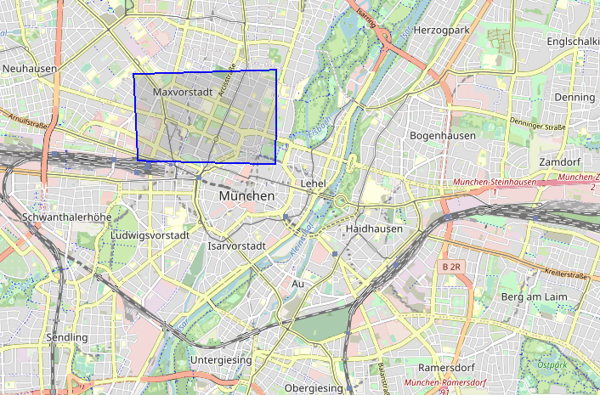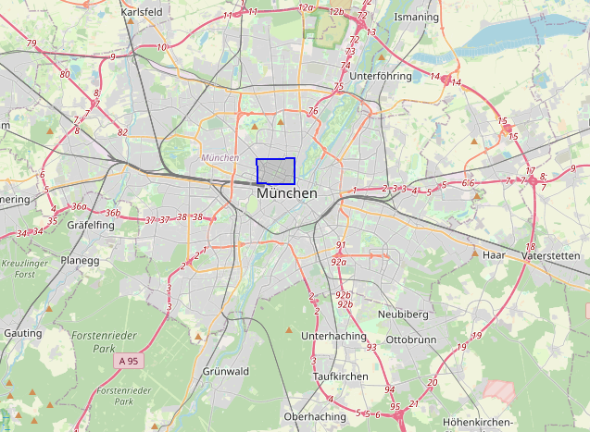

Figure The selected area for study in Munich is shown with a blue rectangle.

Then we determine the number of mobile base stations (LTE Cell Tower) located in this area using the available data sets on OpenCellID, whose positions are shown in the figure.2 using yellow marks. Total LTE Cell Tower in this area are 468. We name this stations as access points (AP) in plots.

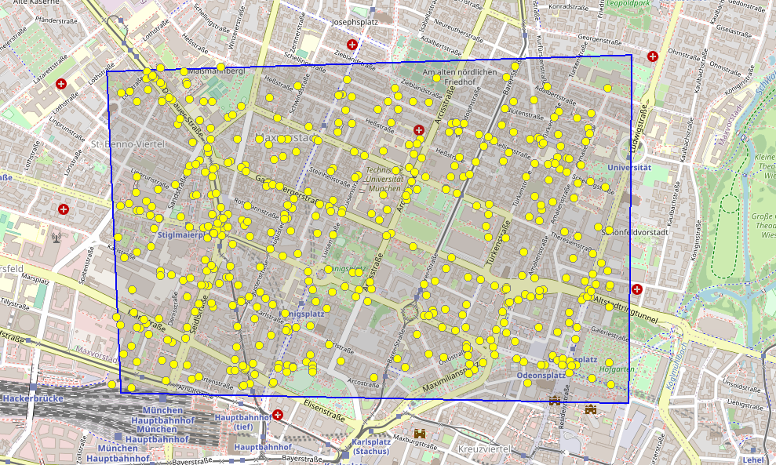

Figure The location of Access Points on Munich selected area using yellow markes.

In the next step, vehicle trips are generated using the OD file, that we received from you, and the Sumo simulator. These trips are produced using the shortest routes from source TAZ to destination TAZ for each car. The trips are for a 1-hour interval from 8:00 to 9:00.

Next, we connect each car to its nearest base station at each step (time stamp in terms of second) of its journey.

Some plots are generated from our investigation on the test area of Munich that are shown in next figures, and here are some related measurements:

Total Travel Time of All Vehicles: 2789371.0 second

Total number of Vehicles which cross our selected area from 8:00 to 9:00: 5946

Mean Travel Time of all vehicles: 469.19613120269133

Max number of vehicles connected to one APs for all Timestamps: 68

Max distance between APs and Vehicles during the whole simulation: 218.9290647675643

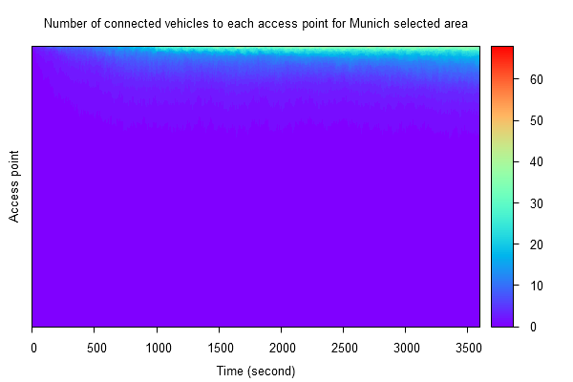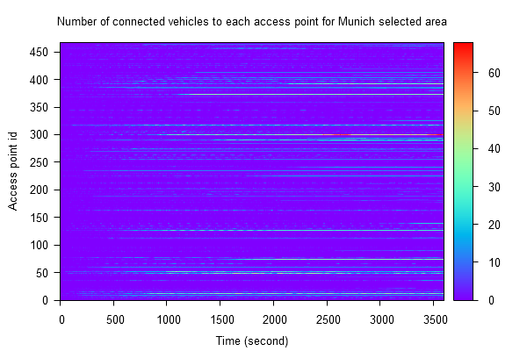The two following figures show the number of connected vehicles to each access point in the Munich selected area. Time steps range from 0 to 3600 seconds. Number of connected vehicles to an access point range from 0 to 68. In the first figure each access point has an id ranges from 0 to 467. The second figure shows the sorted number of connected machines to access points. That is, the values of the connected machines are arranged in ascending order for each time step, regardless of the access point id.

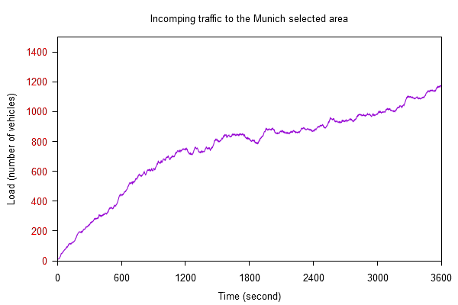 Next figure shows the number of cars in the study area in each time step that is almost evenly increasing.

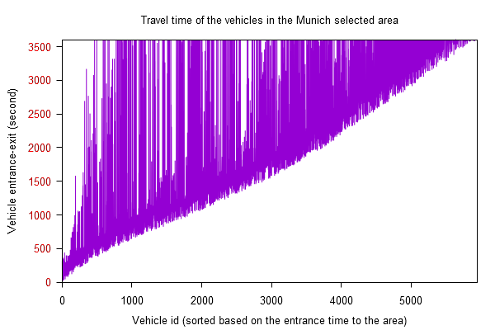The last figure shows the time interval each vehicle stays in the selected area. Although this study do only covers the time range [0, 3600] and does not know about next time steps, it seems with the passage of time the journey of vehicles is prolonging.